

Scheduled Payment

Requirement List

By Yukiko/ Sapumal

내용

1. Requirement history 2

2. Requirements Purpose 3

3. Requirements List 3

# Requirement history

|  |  |  |  |  |
| --- | --- | --- | --- | --- |
| Version | Date | Author | Type | Contents |
| V1.0 | 2021.09.23 | Yukiko | Schedule payments | Admin able to deduct customers’ money (from wallet or Korean bank account) and schedule the payment to be sent to Indonesia bank account for BNI loan payment and UT Korea tuition payment |
| V1.1 | 2021.11.19 | Sapumal | Schedule payments | Schedule overseas remittance using mobile app and Schedule overseas remittance from core system after the customers consent (confirmation on using mobile app)   1. Create, modify or cancel scheduled payments from the mobile app 2. Reschedule transactions from history (Reschedule another transaction from credited transactions) 3. Create a scheduled payment from core system and request customer to approve it from the mobile app 4. View and download scheduled transaction report from core system and mobile app   We will only deduct money while sending the transaction as otherwise there will be an exchange rate error (loss or gain) |
|  |  |  |  |  |

# Requirement Purpose

Main purpose of this function is to enable schedule overseas remittance to BNI Indonesia and Terbuka University Indonesia (and for any country) with the customer’s consent. Also enable customer to schedule any overseas payment using mobile app

GME has agreements with,

1. BNI and BNI loan customers (for now only one)
2. Terbuka University (UT) and Students in Korea

To deduct money with the customer’s consent and send (or schedule) to the designated bank account in Indonesia. The payment amount will be in Indonesian Rupiahs (IDR) and GME will deduct designated KRW amount from the wallet or auto debit account according to exchange rate when initiate the transaction (while sending)

# Requirements List

1. Make it possible to create, modify or cancel scheduled payments from the mobile app for all the countries
2. Should be possible to fix collection currency or payout currency
3. Should be possible to reschedule transactions from history (from credited transactions)
4. Admin should be able to create a scheduled payment from core system and request customer to approve it from the mobile app
5. Once make a schedule from core system, customer should be notified by a sms to approve
6. List of scheduled transactions should be available in core system along with transaction history
7. Should be possible to decide to use coupon or not while creating the schedule payment.
8. Should not be possible to schedule transactions within 11.20 PM to 12.30. should be displayed a popup message “ You cannot schedule transactions between 11.20 and 12.30”
9. Should receive a push notification 24 hours before and 1 minute before the transaction
10. If transaction fails, customer should be notified by a SMS and push notification. “Your scheduled transaction was failed due to insufficient funds. Please reschedule or cancel from mobile app”
11. If transaction fails due to other reasons than insufficient funds, customer should be notified by a SMS and push notification. “Your scheduled transaction was failed due to [reason]. Please contact GME”
12. While scheduling, need to check compliance rules related to sender and receiver
13. Should be able to download and share scheduled transaction receipts
14. Should be able to download scheduled transaction report from scheduled transaction history
15. Should be able to differentiate scheduled transaction and other transactions in the transaction. Use keyword in the report (Scheduled transactions: Scheduled)

**Core System**

**Scheduled Payments 🡪 Schedule a Payment**

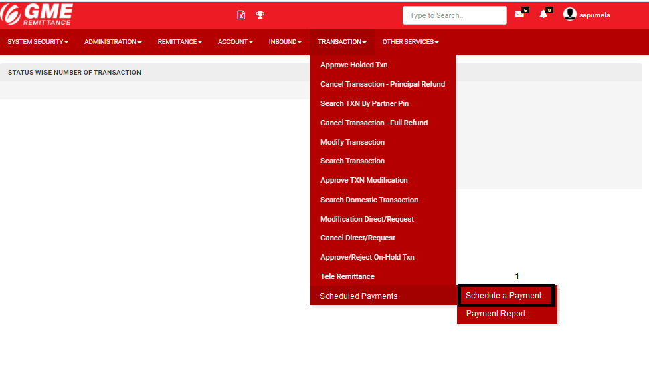

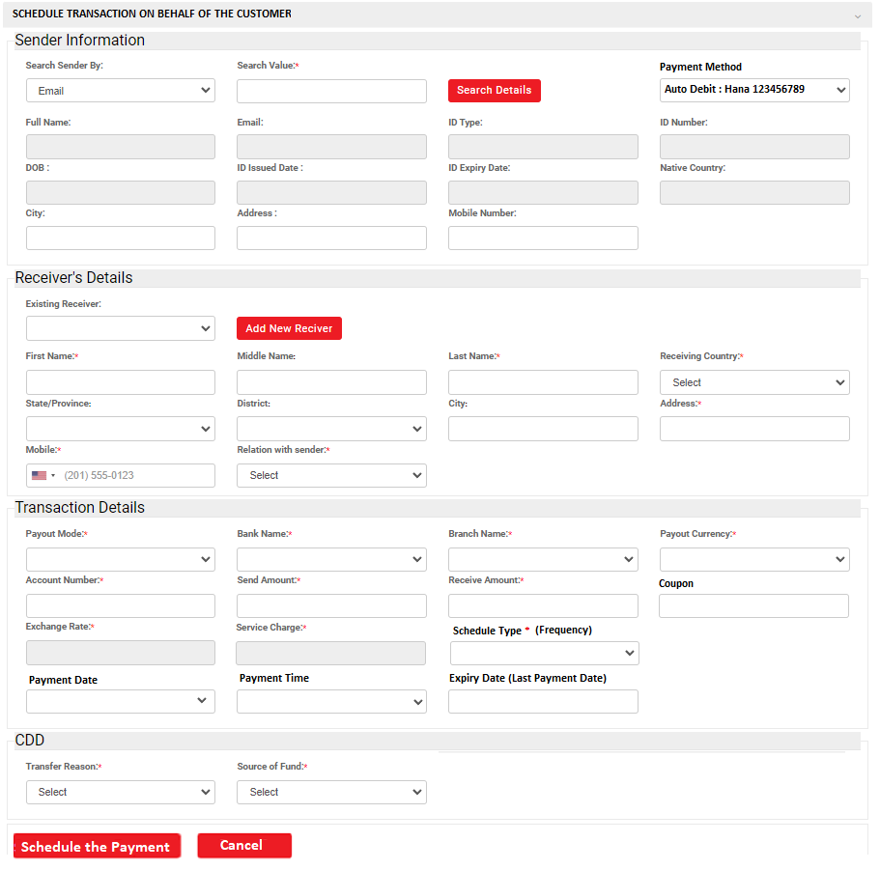

**Scheduled Payments 🡪 Payment Report**

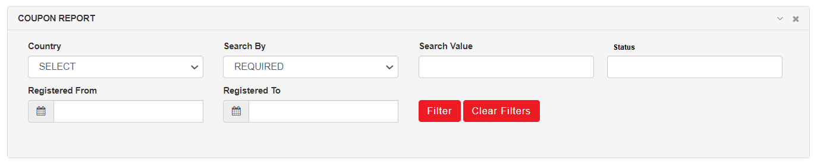

Search by (not mandatory)

1. Username
2. ID Number
3. Virtual Account Number
4. Name

**Search Results**

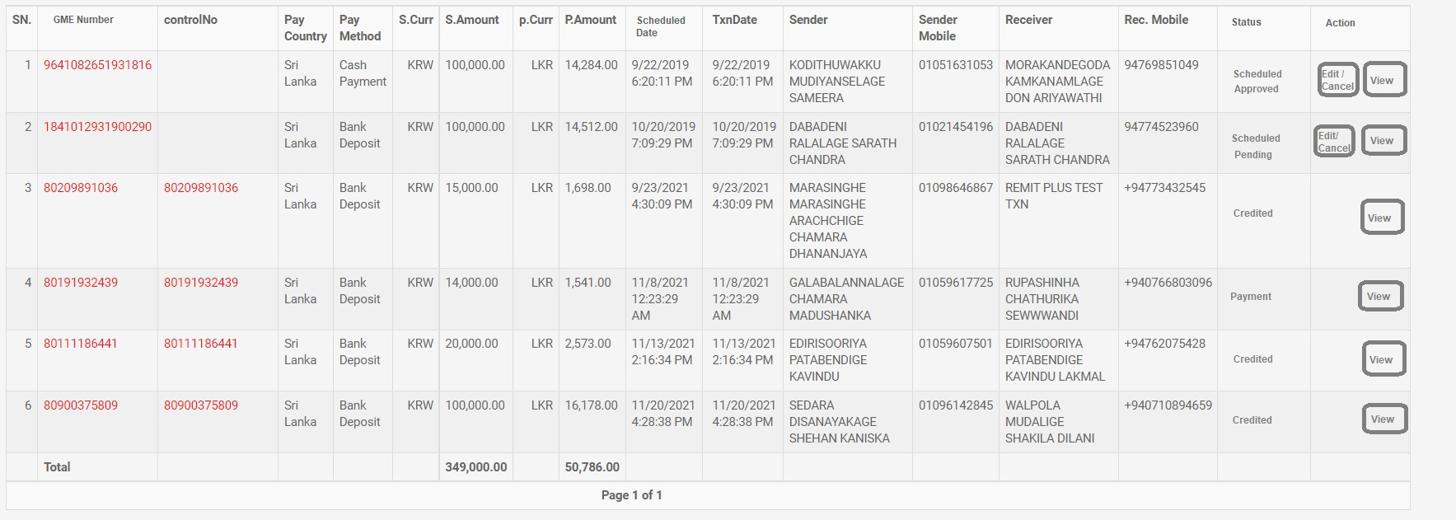

**Mobile App**

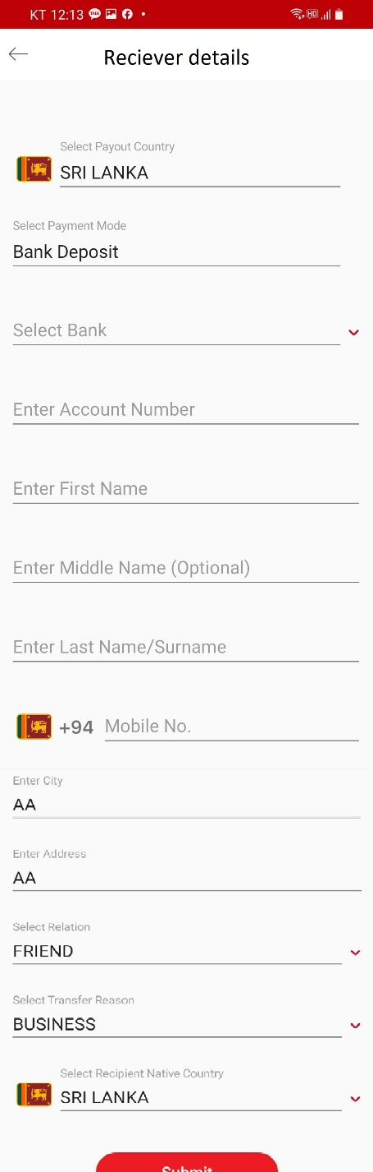

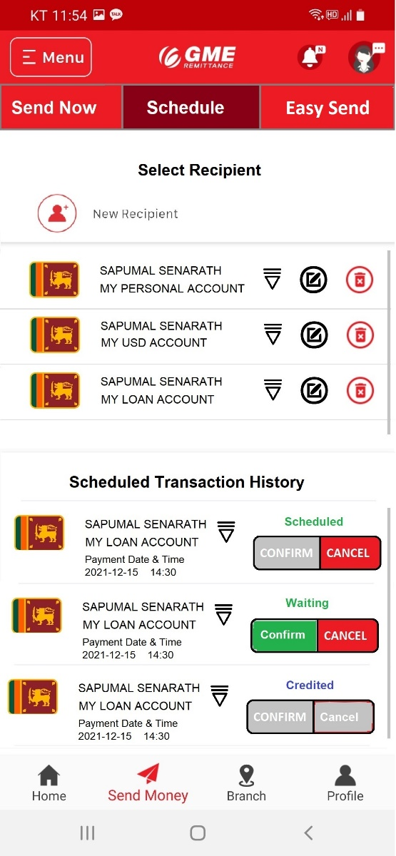

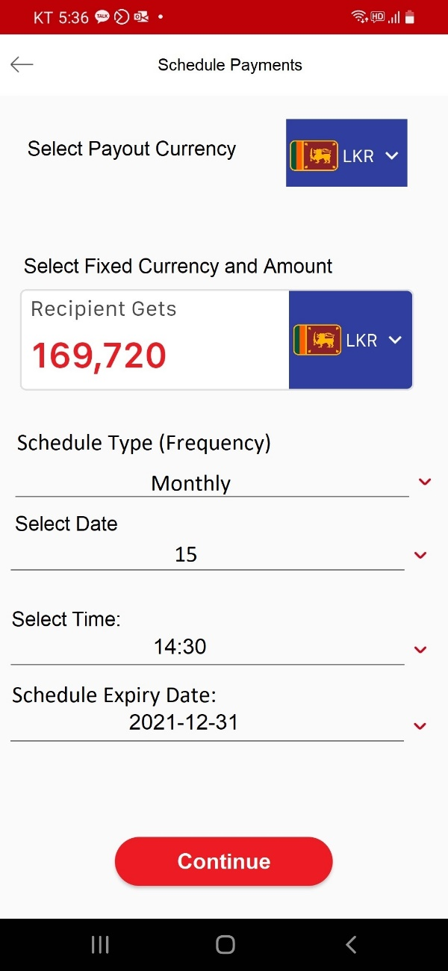

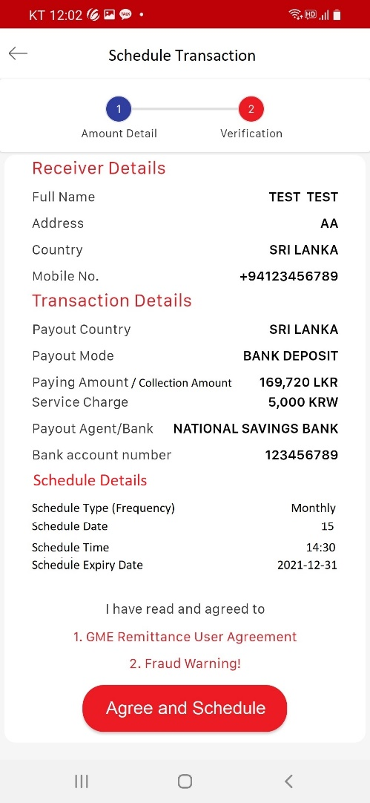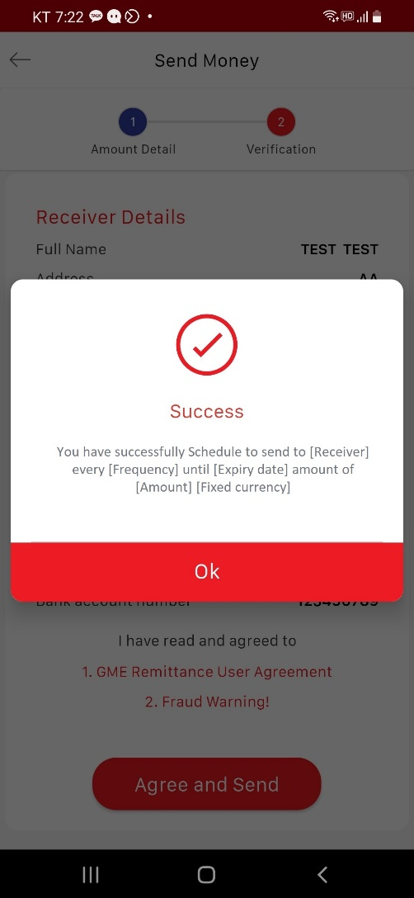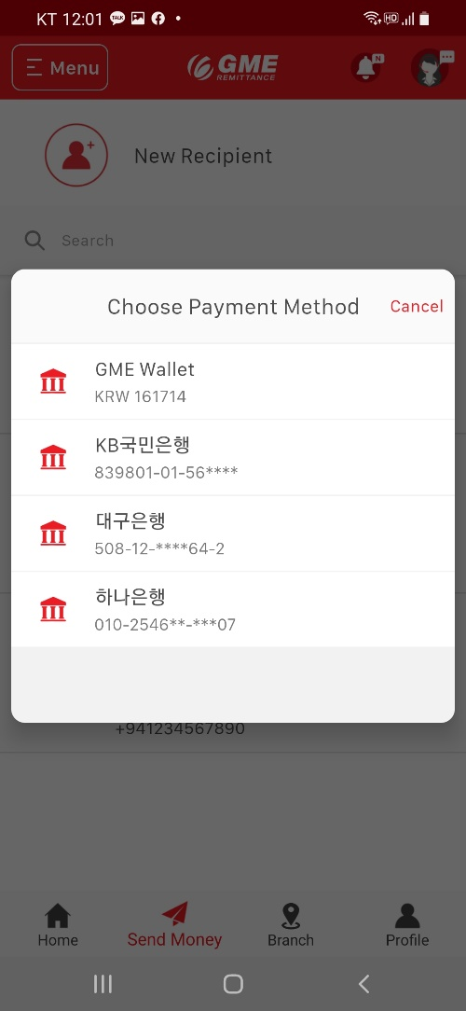

If the Frequency is Onetime payment and Weekly,

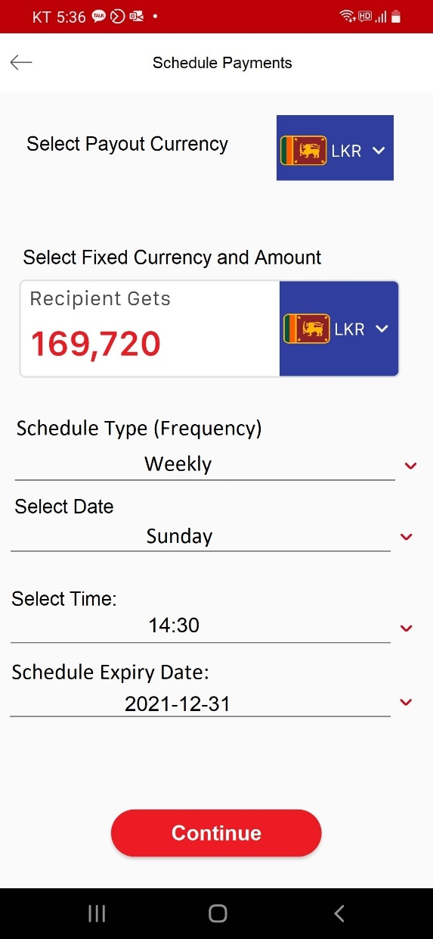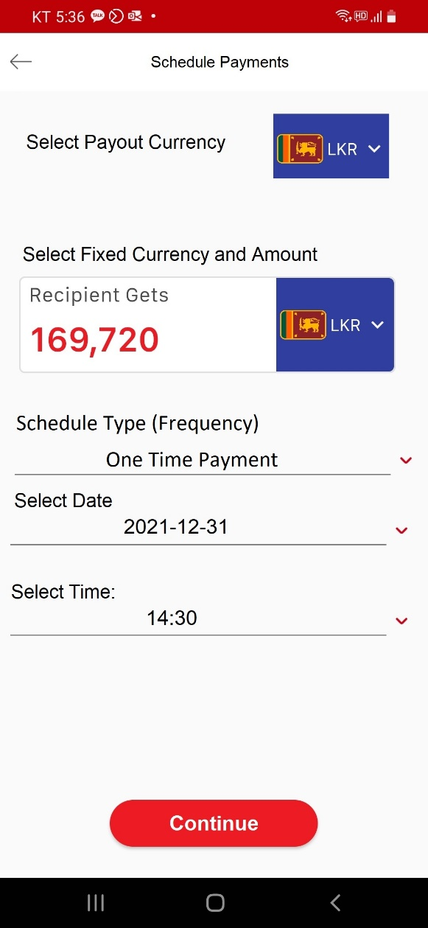

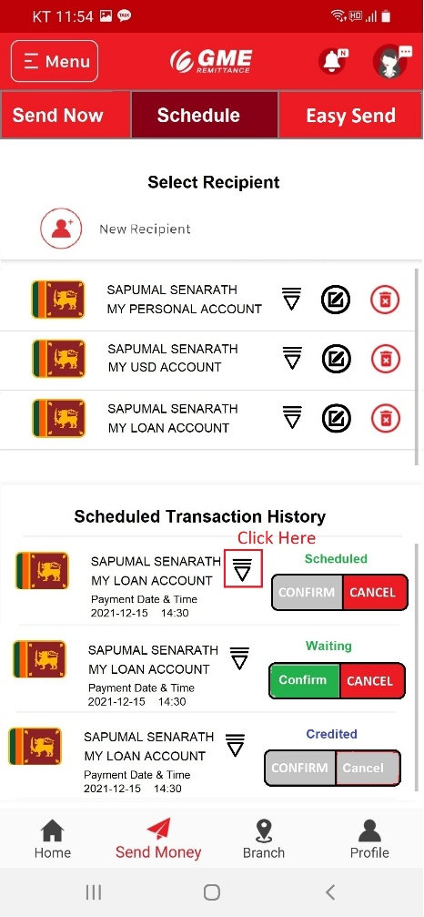If click edit button in scheduled transaction history

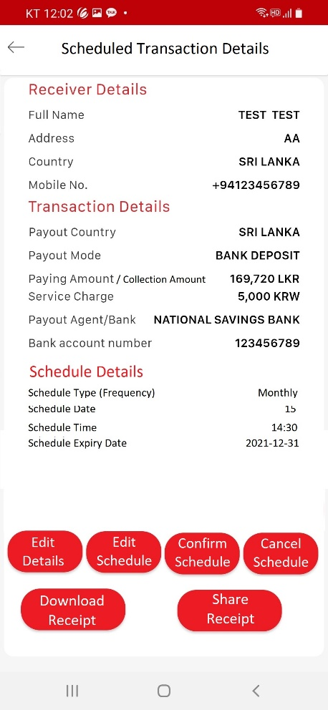

If click “Edit details”, direct to edit recipient page

If click “Edit Scheduler”, direct to set scheduler (schedule payment) page